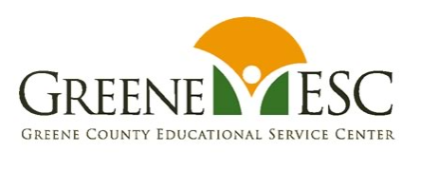
GREENE COUNTY ESC BUSINESS ADVISORY COUNCIL
JOINT STATEMENT
MARCH 1, 2024

As of 3/1/24, the GCESC BAC met three times on October 11, 2023, December 6, 2023, February 11, 2024, and are scheduled to meet again on April 3, 2024.

All of the public school districts in Greene County have aligned with the Greene County ESC’s BAC, including:

Beavercreek City School District
Bellbrook-Sugarcreek Local School District
Cedar Cliff Local School District
Fairborn City School District
Greeneview Local School District
Xenia Community School District
Yellow Springs Exempted Village School District

All of the items listed in the 2023 - 24 BAC Plan have been implemented, or are in progress.

Highlights:

- GCESC has continued to fund the Pathful Explore (formerly, “Virtual Job Shadow”) career platform for all of the school districts in the county. The focus for usage of the program is 6th - 9th graders with the age group/seats being determined by each local district. The BAC Co-Chair is coordinating the usage and assisting with securing the student seats and teacher access. This career development platform has grown 35% in # of student users since its first year of roll-out to the local districts.
- The Strategic Ohio Council for Higher Education (SOCHE) has obtained an intermediary grant from the Ohio Dept of Education and Workforce Development for paid student internships (junior and senior high school students). President Dr. Cassie Barlow is a member of our Greene County BAC and routinely provides updates and guidance re: steps the school districts can follow to support their students’ participation in these employment/career opportunities.
- The GCESC BAC has more than doubled its membership over the past four years and currently reflects a total of 70 active members at the conclusion of this 2023 - 24 school year. The membership representation is also becoming more diversified, reflecting a broad variety of diverse businesses and industries, community support agencies, local school districts, and higher education.
- A new partnership was formed between the GCESC, Fairborn High School, and the Dayton Regional Manufacturing Association (DRMA) to increase employment opportunities for the at-risk and underserved student population at Fairborn HS. Funds supporting this initiative were provided through a grant obtained by DRMA.
- There are four constituent components that comprise the GCESC BAC focus:
  - Pre-K - 12
  - Post-Secondary
  - Workforce
  - Community Resources and Support
- A new Career Connections Coordinator position was created for enhancing career exploration and funded through a grant written by the GCESC. This new coordinator role was intended to connect the needs of local students for practical career development/employment support with the Greene County business community needs to secure ample quality employees. The new coordinator is also working to strengthen the communication pipeline regarding local employment opportunities, and also supporting the Greene County school districts with enhancing and expanding their career exploration endeavors.

